**USER INTERFACE TOOL DEVELOPMENT**

**MEETUPS mock-ups description**

This document describes the user interface mock-ups developed as part of the process of developing a tool to explore the MEETUPS knowledge graph, which provides information about music encounters in Europe during 1800 – 1900.

Here we describe two main functionalities of the proposed tool, the exploration of encounters, saved searches view and the visualisation of historical meetups by musicians.

**Encounters exploration**

The following four figures describe the user interface proposed to address the data requirements of experts regarding the exploration of historical meetups using a timeline and map tool.

**Figure 1.**

In this interface, the user can explore a range of dates using the controls on the top of the window. Results are displayed in a map interface; each point in the map represents a historical encounter or a group of encounters (colour coded) in the selected geographical area. On the left-hand side of the window, the interface provides controls to search and filter musical encounters by participants, location, dates and type of encounter.

When the user selects a meetup, the tool displays the details of the selected item in the lower side of the interface. Here the tool also provides more features in order to facilitate the exploration of related information such as people involved, places, among others.

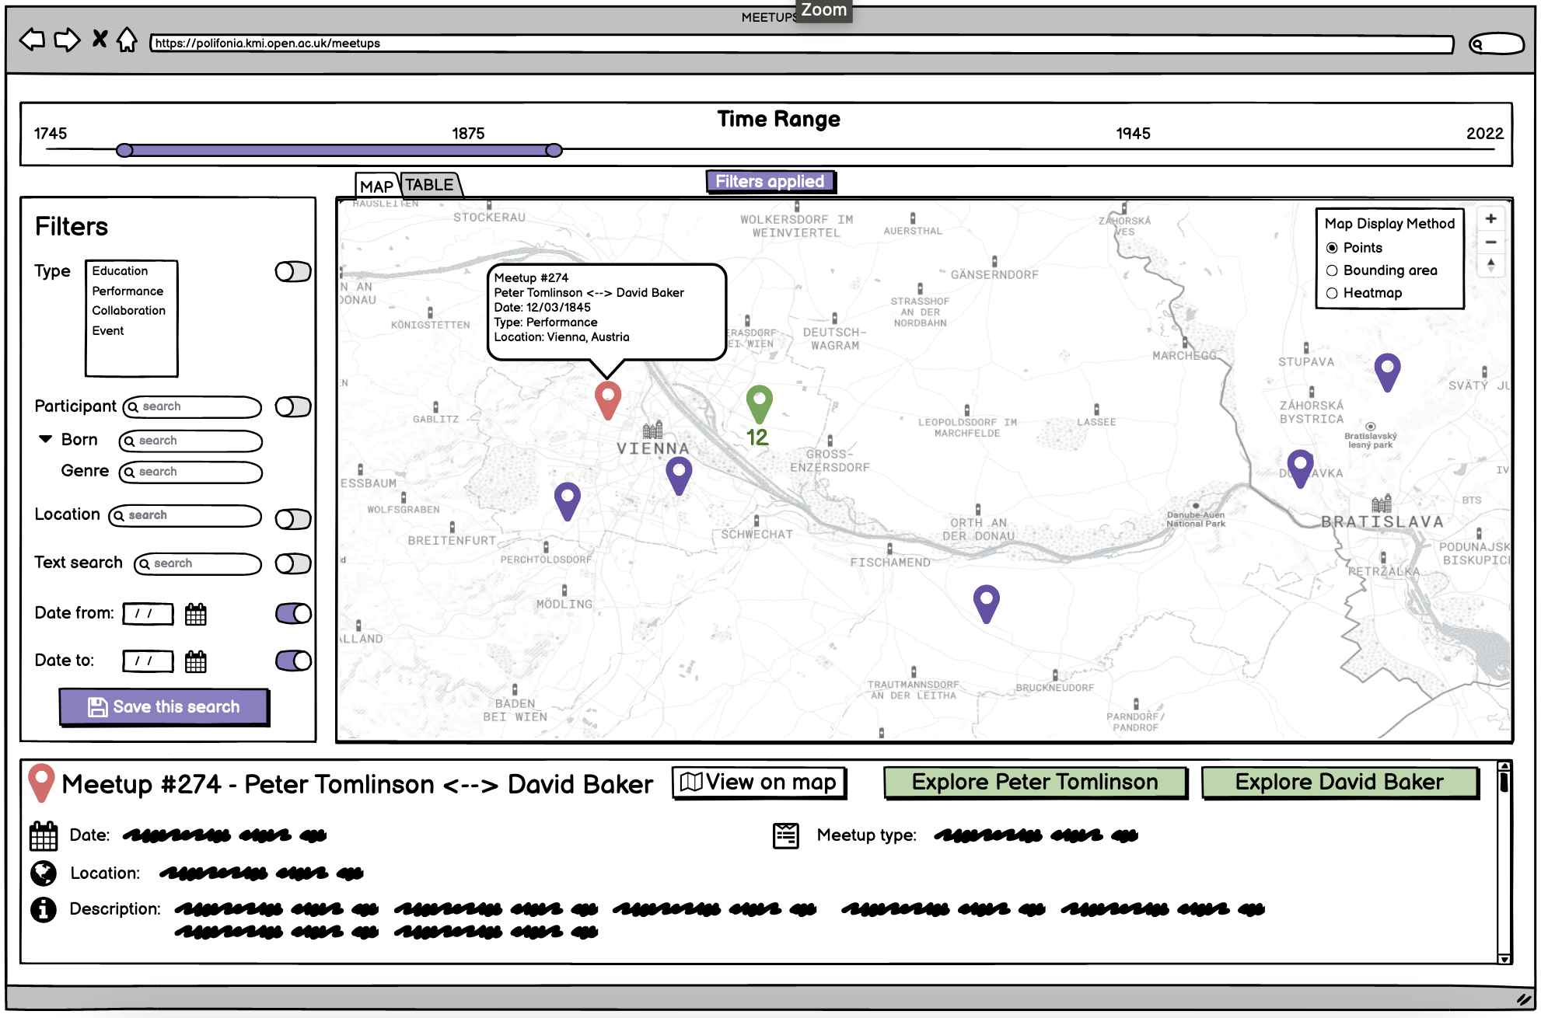

**Figure 2.**

Similar to Figure 1, this mock-up displays the different options to search and filter information about musical encounters. The map interface has changed to a different display method, in this case, a bounding area that groups the meetups in the specified timeline.

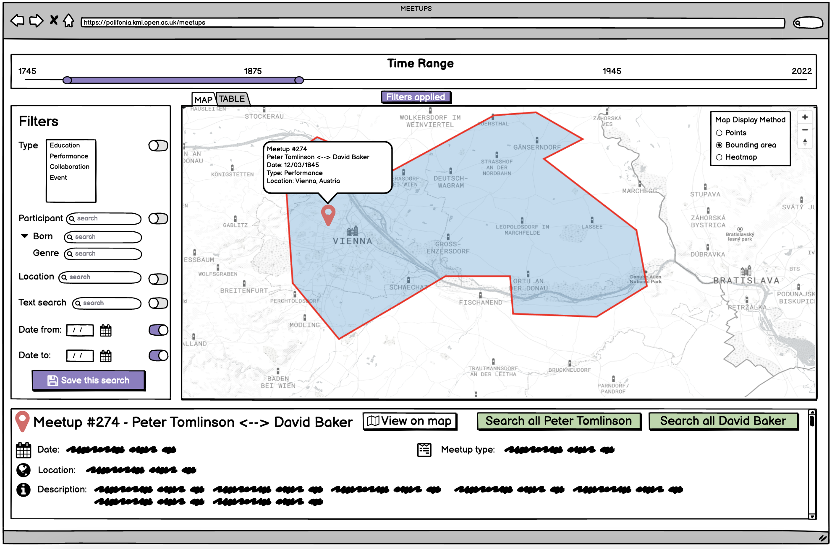

**Figure 3.**

Similar to previous figures, this mock-up displays the different options to search and filter information about musical encounters. The map interface has changed to a different display method, in this case, a heatmap that colours the areas where most encounters happened in a given time range.

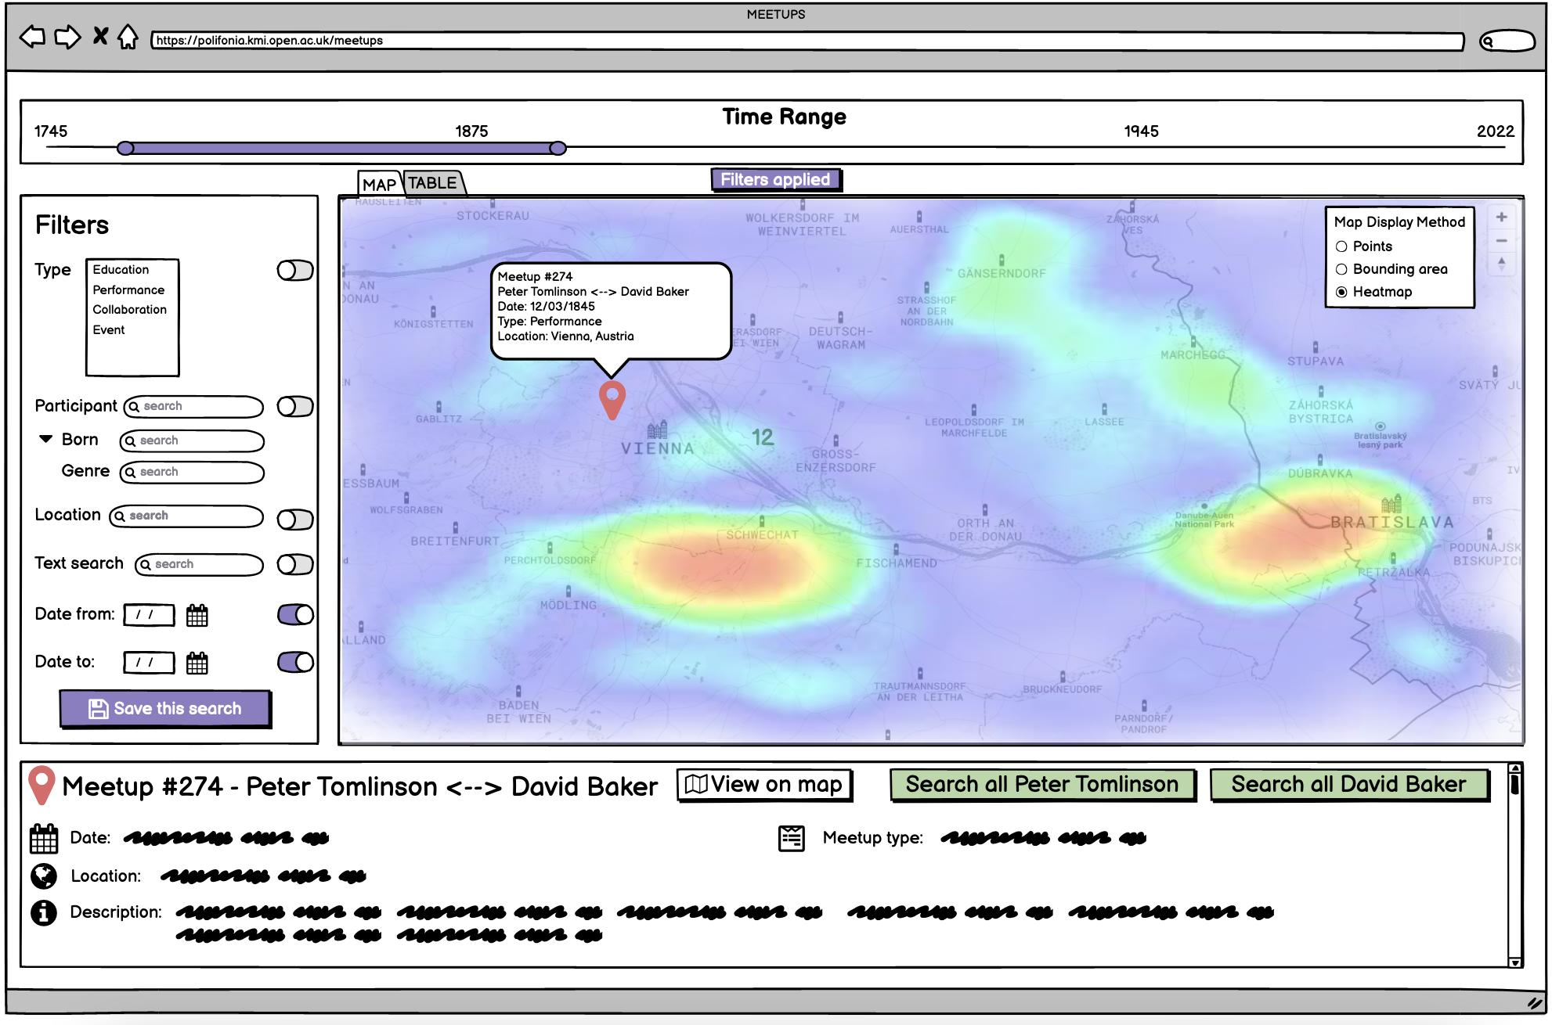

**Figure 4**

This mock-up displays the different options to search and filter information about musical encounters. It also illustrates how the information displayed in the map interface is also available as a table for easy search.

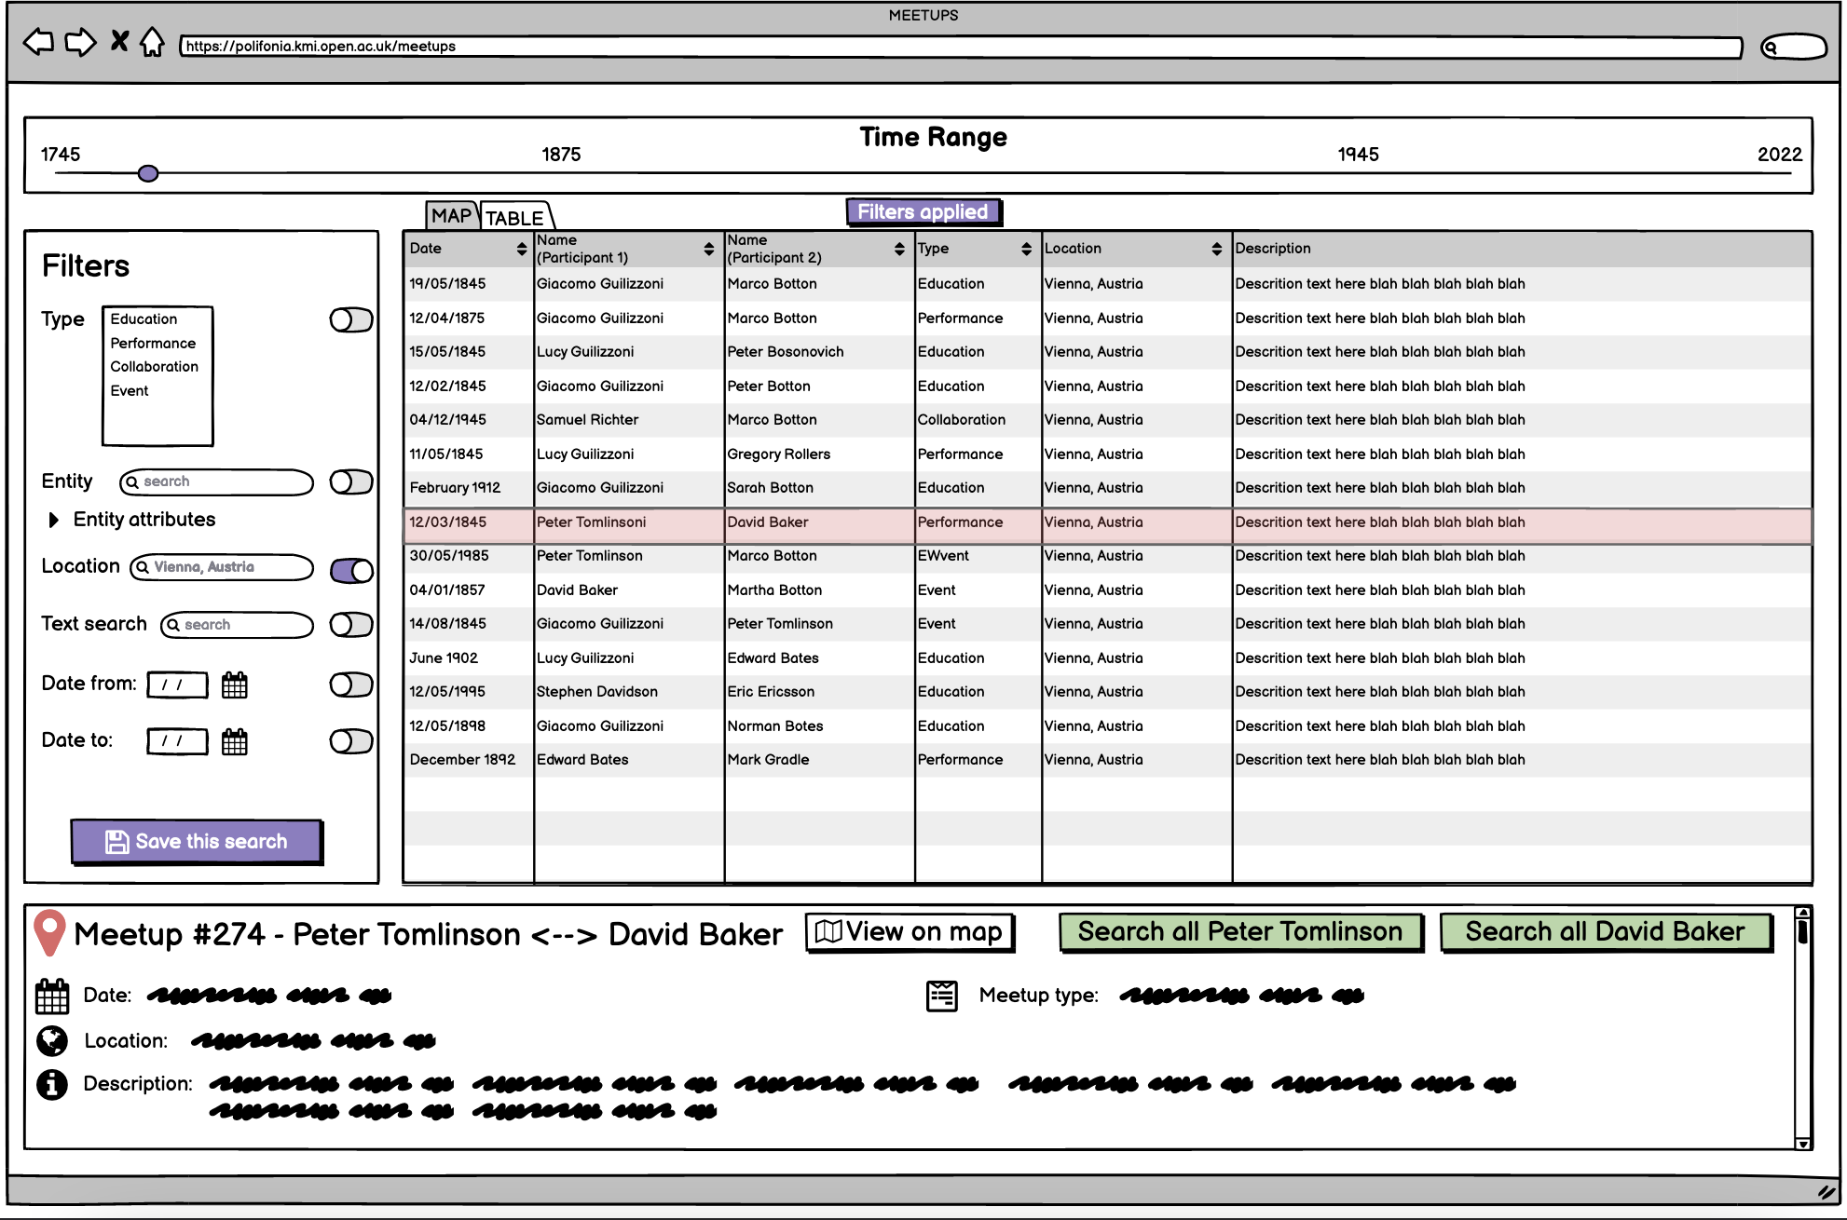

**Saved searches view**

**Figure 5**

The following mock-up illustrates how users can also use saved searches to compare encounters, this feature can help users to find interesting relations between musicians.

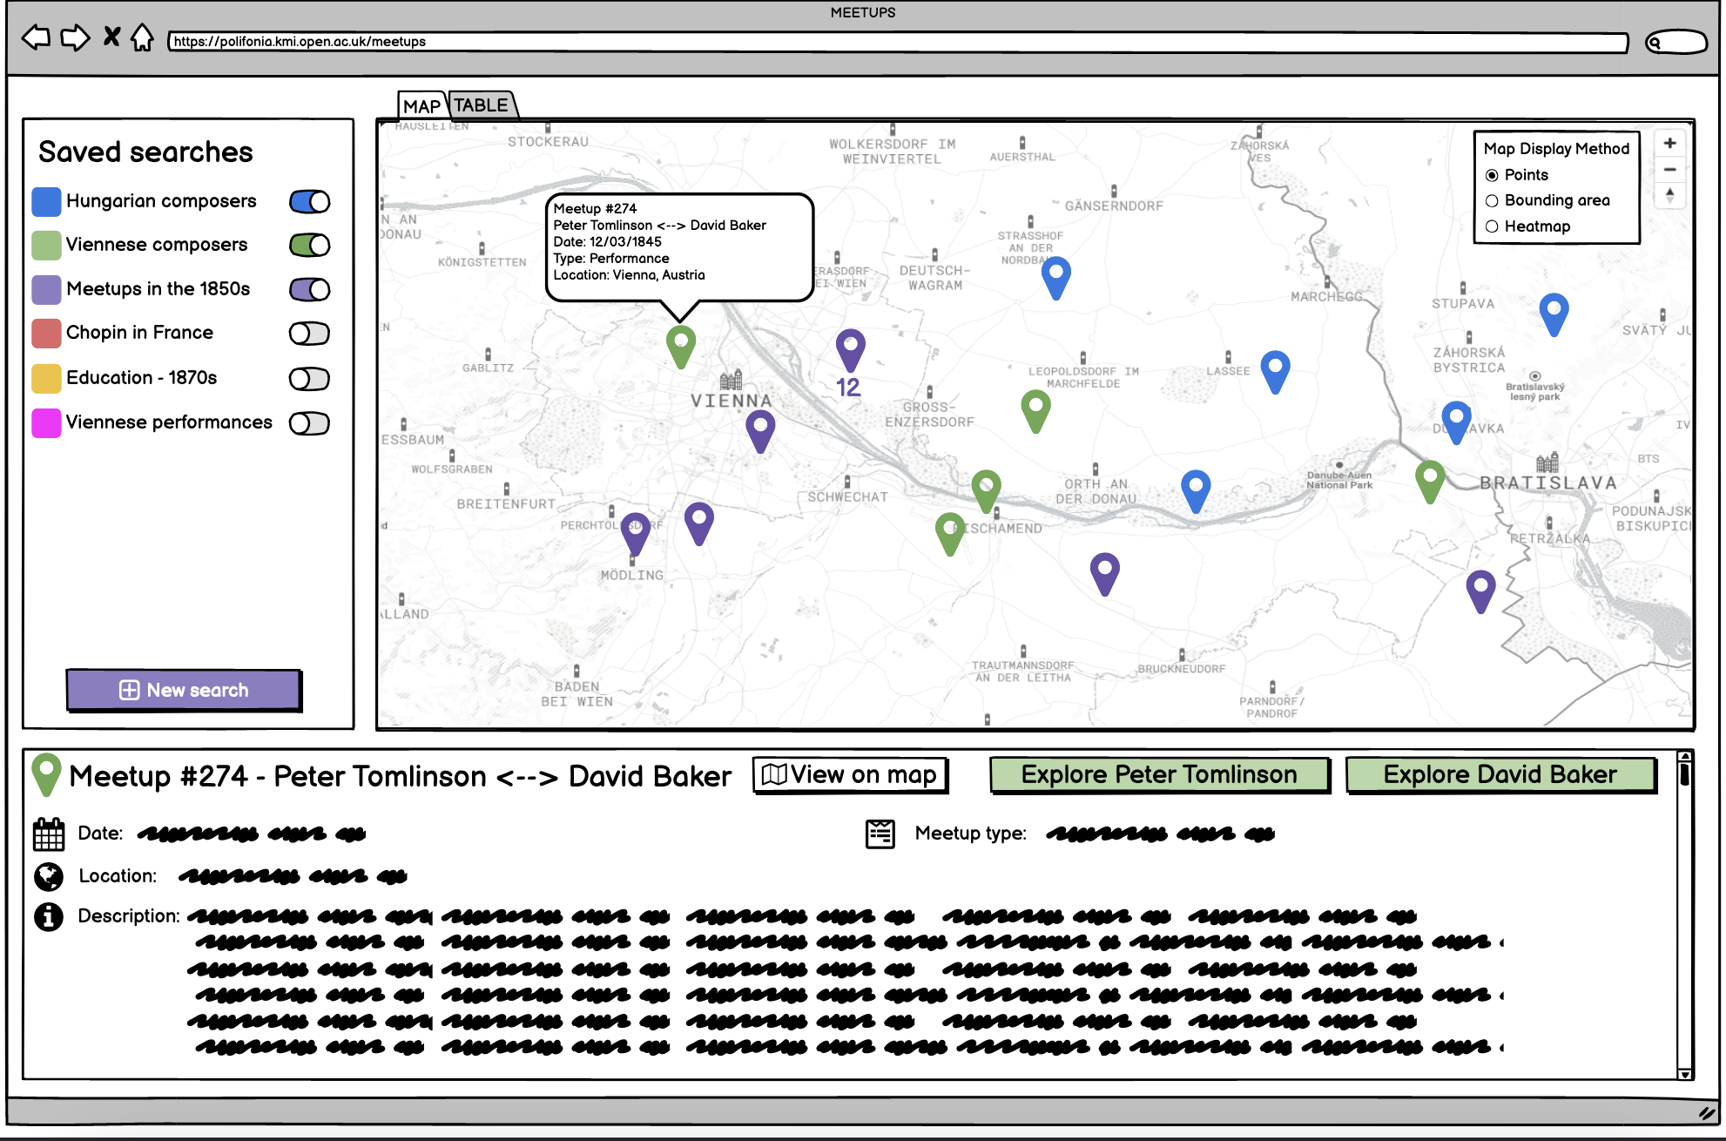

**Visualisation of a musician’s encounters**

**Figure 6**

The following two figures illustrate how users can explore a musician's encounters, the information they can visualise and how the list of encounters is displayed (as a table and a map interface). Users can also explore meetups in a timeline interface.

Relevant information such as popular locations, connections (people they met), active periods and frequent meetups are also available for users to explore.

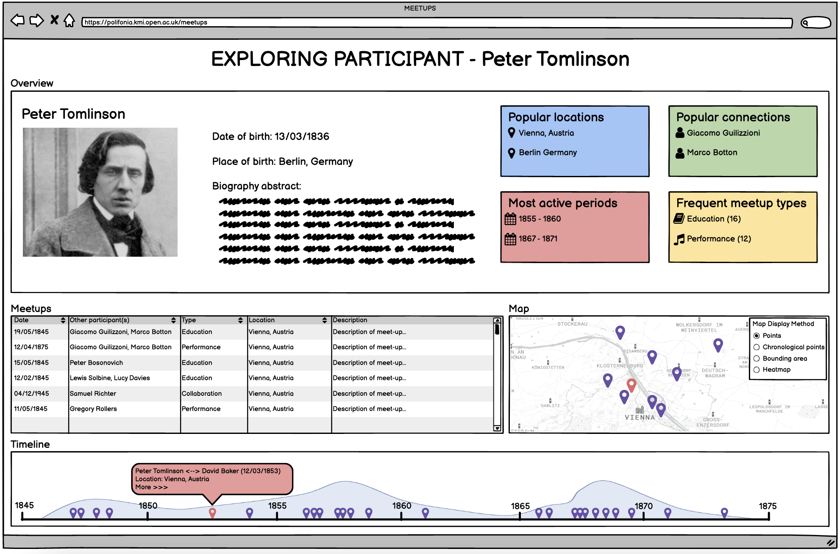

**Figure 7**

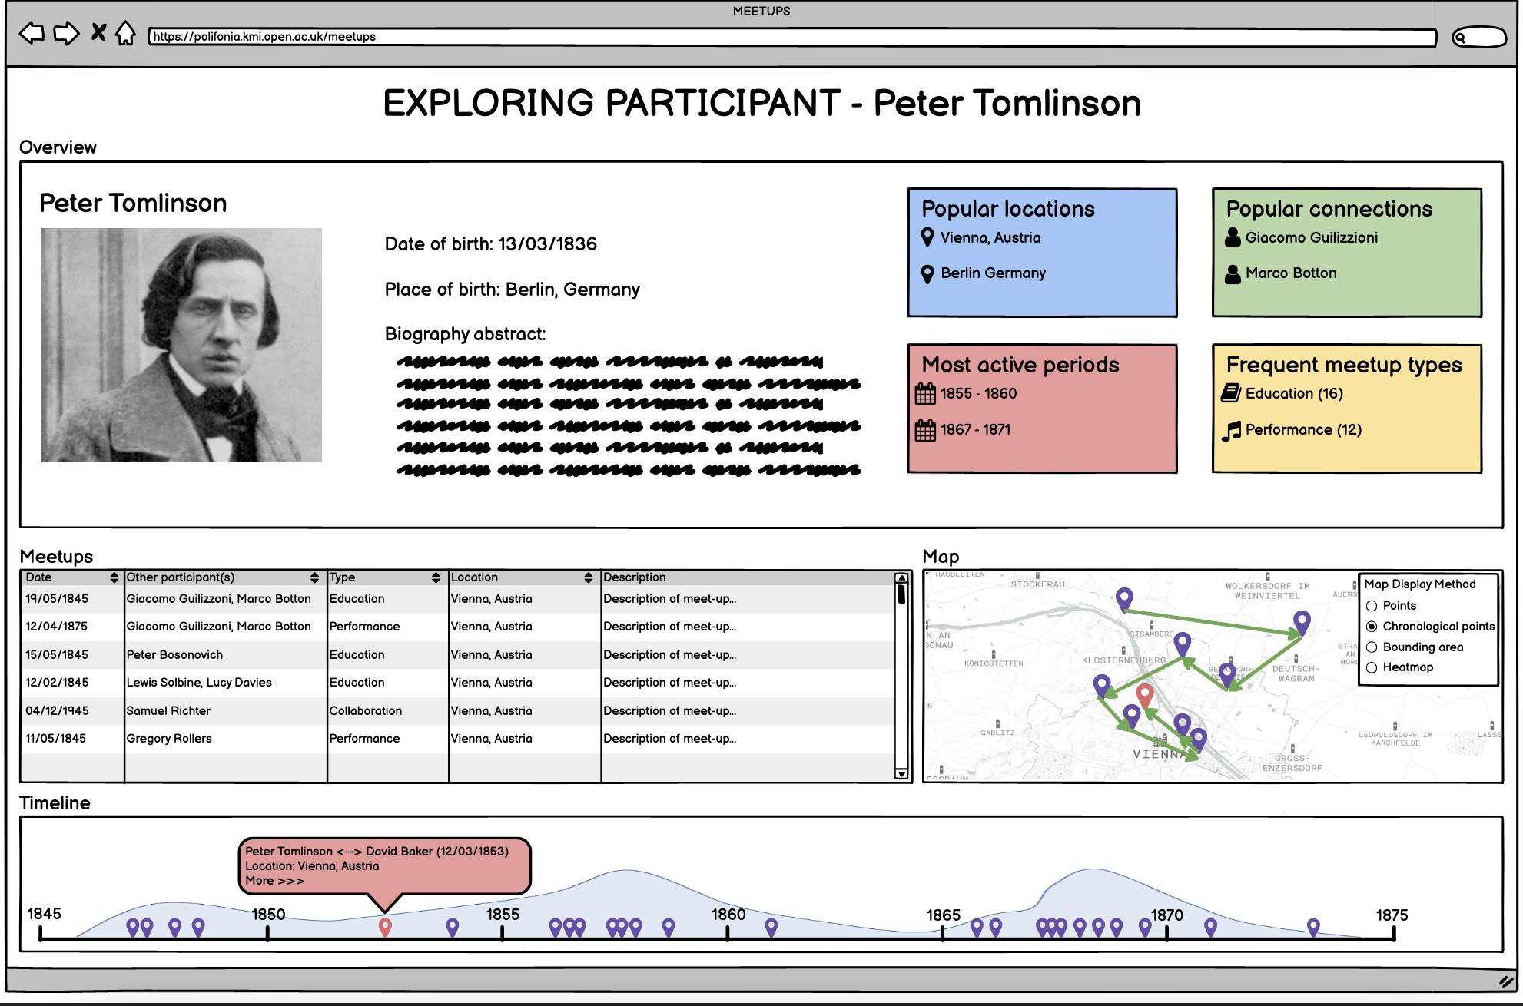

**Figure 8**

The tool also provides a different view of exploring places, for example, a city. The tool displays popular people, significant meetups, more active periods and frequent types of meetups.

